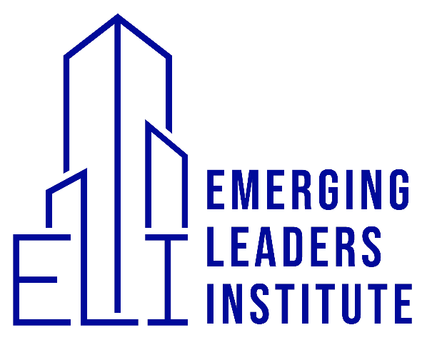
Academic Calendar (2023-2024)

Spring Quarter- March 14, 2023-June 17, 2023
A TERM (6 weeks)
COURSE NAME: ELI[F] 400: Foundations for Leadership
Instructor: Ap. Connie Tucker
Meeting Dates: March 14th, 21st, 28th
April 4th, 18th, 25th
Break: 4/9-4/15
Solemn Assembly [ April 15th]

B TERM (6 weeks)
COURSE NAME: ELI[S] 500: Deep Dive into the Prophetic
Instructor: Ap., Dr. Scott Kelso
Meeting Dates: May 2nd ,9th , 16th , 30th
June 6th , 13th
Break: 5/21-5/27
Solemn Assembly [May 27th]
Summer Quarter-June 19, 2023-September 12, 2023
A TERM (6 weeks)
Course Name: ELI[P] 400: Take the City
Instructor: Ap. Johnny Amos
Meeting Dates: June 20th , 27th
July 11th , 18th , 25th
August 1st
Break: 7/2-7/8
Solemn Assembly [July 8th]

B TERM (6 weeks)
Course Name: ELI[P] 401: The Praying Church
Instructor: Ap. Alfred Tagoe/ Ap. Brondon Mathis/ Ap. Brian Williams
Meeting Dates: August 8th , 15th , 22nd , 29th
September 5th , 12th
Break: 9/17-9/23
Solemn Assembly [September 23rd]

Fall Quarter-September 24th, 2023-December 30, 2023
A TERM (6 weeks)
Course Name: ELI[F] 401: Effective Leadership
Instructor: Ap. Shelley Crozier
Meeting Dates: September 19th , 26th
October 10th , 17th , 24th , 31st
Break 10/2-10/7
Solemn Assembly [October 1st] Sukkot

B TERM (6 weeks)
Course Name: ELI[S]: 501: Gifts of the Spirit
Instructor: Ap., Dr. Norman Brown
Meeting Dates: November 7th , 14th , 21st
December 5th , 12th , 19th
Break: 11/26-12/2
Solemn Assembly [December 30th]

Winter Quarter- January 2, 2024-March 30, 2024
A TERM (6 weeks)
Course Name: ELI[S] 502: The Presence of God
Instructor: Ap. Paul Hoy
Meeting Dates: January 2nd, 9th , 16th , 23rd , 30th
February 6th
Break: 2/11-2/17
Solemn Assembly [February 17]

B TERM (6 weeks)
Course Name: ELI[F] 402: Leadership Integrity
Instructor: Ap. Gary Nelson
Meeting Dates: Feb 20th , 27th
March 5th , 12th , 19th
April 2nd
Break: 3/24- 3/30
Solemn Assembly [March 30th]
Graduation/Ordination April 6th

ELI[F]- EMERGING LEADERS INSTITUTE FOUNDATIONS
ELI[P]- EMERGING LEADERS INSTITUTE PRACTICALS
ELI[S]- EMERGING LEADERS INSTITUTE SPECIAL TOPICS

